CS 255 System Design Document

Polo Navarro
17 October 2026
Apolinar.navarro@SNHU.edu
Southern New Hampshire University

UML Diagrams

UML Use Case Diagram from Module Six
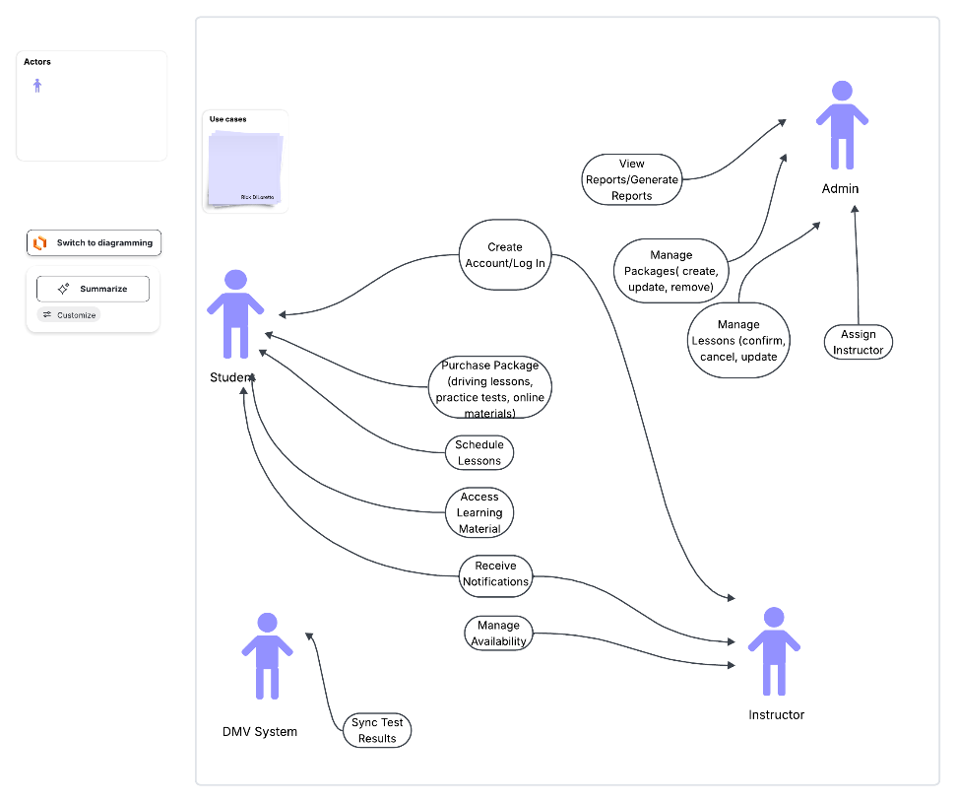

UML Activity Diagrams
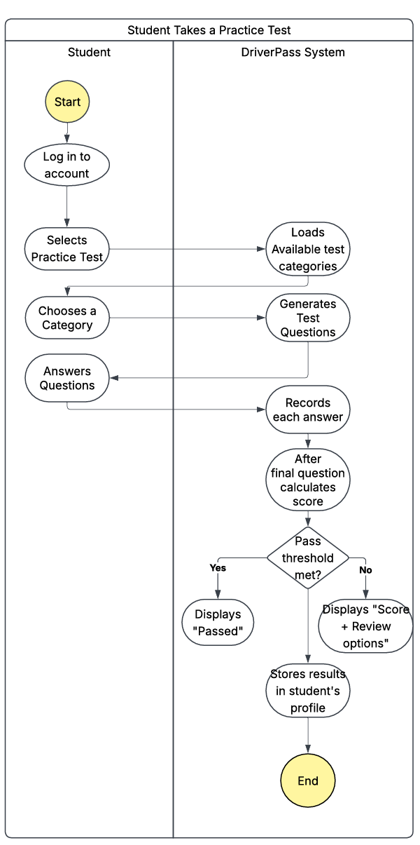
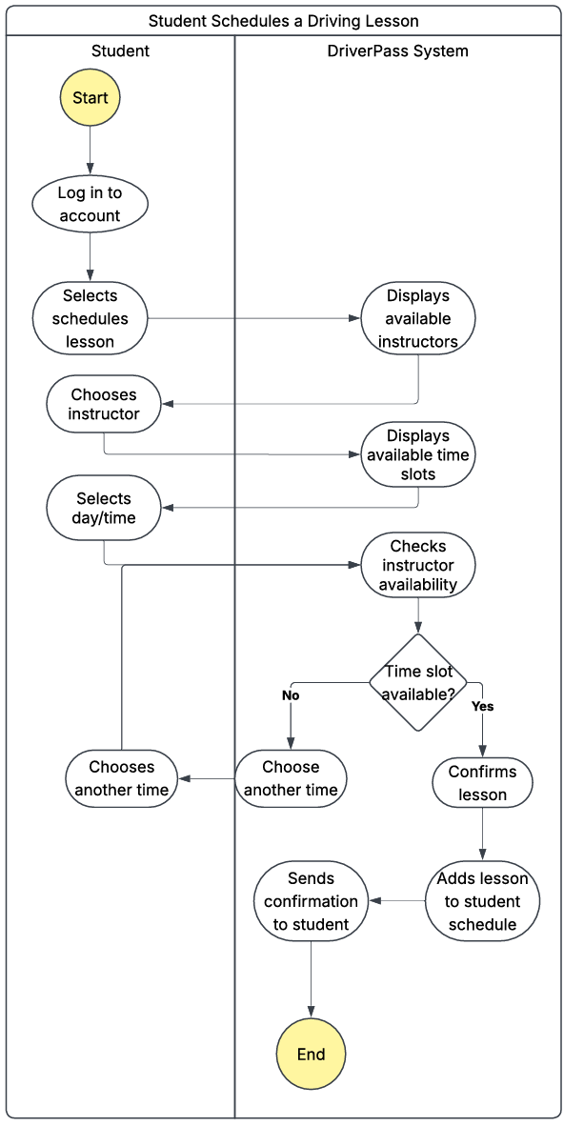

UML Sequence Diagram

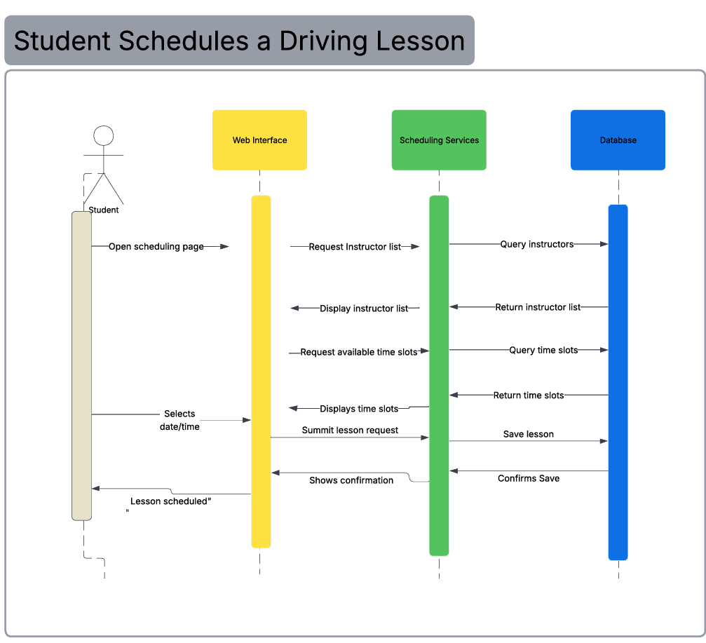

UML Class Diagram

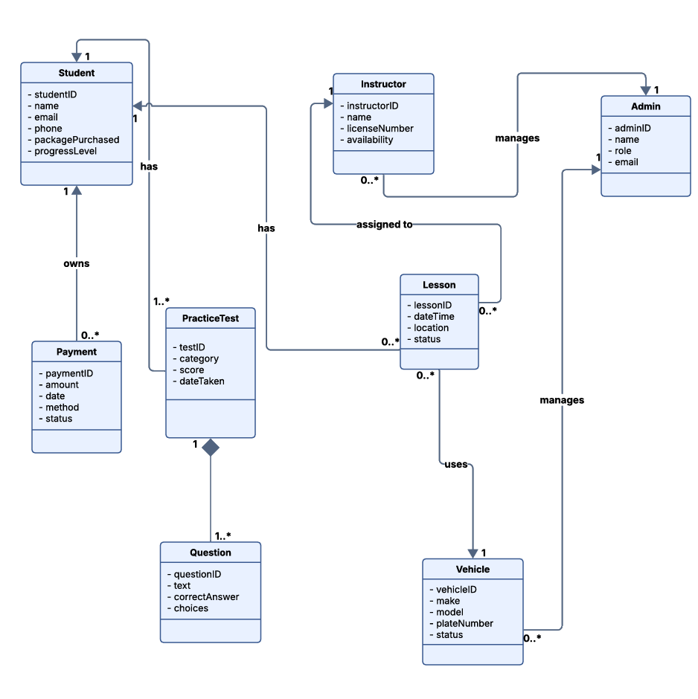

Technical Requirements

Based on the functional and nonfunctional requirements from Project One, the DriverPass system needs a simple, reliable, cloud-based setup. The system will run as a web application so students, instructors, and administrators can access it from any device with a modern browser. Because everything is online, the main hardware requirement is a cloud server with enough processing power and storage to handle user accounts, lesson scheduling, practice tests, and administration data. Users only need an internet-connected laptop, desktop, tablet, or phone.

On the software side, the system needs a web framework (like Node.js, Django, or ASP.NET Core) to handle authentication, scheduling logic, and practice test functionality. The frontend will use standard web technologies (HTML, CSS, JavaScript) and must be responsible so students can schedule lessons or take tests on mobile. A relational database such as MySQL or PostgreSQL is required to store structured data like student profiles, instructor availability, vehicle records, payments, and test results. Because the system handles personal information, it must use secure login, password hashing, role-based access control, and encrypted communication over HTTPS.

Network requirements are straightforward: stable internet access for users and secure communication between the client and server. The system must support fast page loads, efficient database queries, and automatic scaling to meet performance and reliability expectations. Regular backups, audit logs, and disaster recovery processes are needed to protect data. To keep the system maintainable and scalable, the codebase should be modular, documented, version-controlled through GitHub, and supported by automated testing. This setup allows DriverPass to grow over time without major redesigns.

